The CPU (Central Processing Unit) is the main processing unit of a computer. Its major parts are.

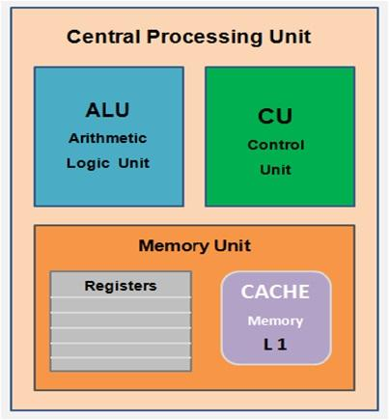
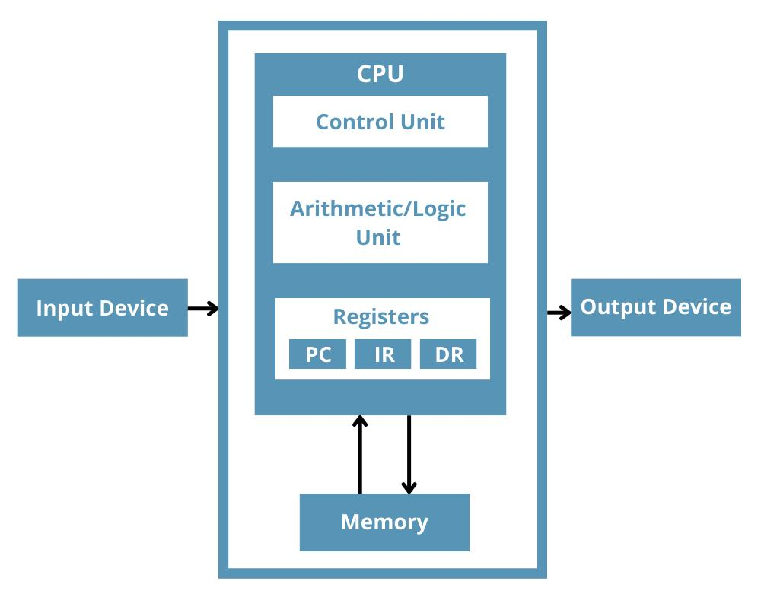

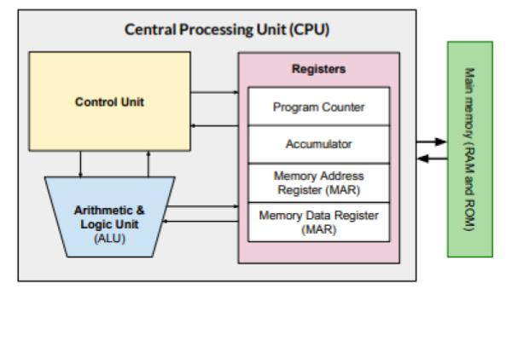
5
- Control Unit (CU)
  - Directs and coordinates all operations of the CPU.
  - Fetches instructions from memory and controls their execution.
- Arithmetic Logic Unit (ALU)
  - Performs arithmetic operations (addition, subtraction, multiplication, division).
  - Performs logical operations (AND, OR, NOT, comparisons).
- Registers
  - Small, high-speed storage locations inside the CPU.
  - Temporarily hold data, instructions, and memory addresses during processing.
- Cache Memory
  - Very fast memory located inside or close to the CPU.
  - Stores frequently used data and instructions to speed up processing.

Summary
- Control Unit (CU): Controls and manages operations.
- Arithmetic Logic Unit (ALU): Performs calculations and logical decisions.
- Registers: Temporarily store data and instructions.
- Cache Memory: Speeds up access to frequently used information.

Today 3:57 PM
component of cpu motherbord

The motherboard is the main circuit board of a computer. It connects all the hardware components and allows them to communicate.

Main Components of a Motherboard
- CPU Socket
  - Holds the CPU (Central Processing Unit).
  - Connects the processor to the motherboard.
- RAM Slots (DIMM Slots)
  - Used to install RAM (Random Access Memory).
  - Usually 2 or 4 slots are available.
- Chipset
  - Controls communication between the CPU, RAM, storage devices, and other components.
- BIOS/UEFI Chip
  - Stores the firmware that starts the computer and checks the hardware during boot.
- CMOS Battery
  - Keeps the BIOS settings and system clock saved even when the computer is turned off.
- Expansion Slots (PCIe Slots)
  - Used to install expansion cards such as:
    - Graphics card (GPU)
    - Sound card
    - Wi-Fi card
    - Network card
- Storage Connectors
  - SATA Ports: Connect HDDs, SSDs, and DVD drives.
  - M.2 Slot: Connects high-speed NVMe SSDs.
- Power Connectors
  - 24-pin ATX connector: Main power for the motherboard.
  - 4-pin/8-pin CPU connector: Power for the CPU.
- USB Headers
  - Connect the front USB ports of the computer case.
- Audio Header
- Connects the front headphone and microphone ports.
- Fan Headers
- Used to connect CPU and cabinet cooling fans.
- Rear I/O Ports
- External ports such as:
  - USB ports
  - HDMI/DisplayPort
  - Ethernet (LAN)
  - Audio jacks
  - PS/2 (on some motherboards)

Easy Trick to Remember
"CRC BCP SPUF"
- C = CPU Socket
- R = RAM Slots
- C = Chipset
- B = BIOS/CMOS Battery
- C = PCIe (Expansion Cards)
- S = Storage Connectors
- P = Power Connectors
- U = USB & Audio Headers
- F = Fan Headers
This covers the most important motherboard components commonly asked in school exams and basic computer courses.

Cache Memory
Cache Memory is a small, very fast memory located inside or very close to the CPU. It stores frequently used data and instructions so that the CPU can access them quickly.

Definition
Cache Memory is a high-speed memory that stores frequently used data and instructions to improve the computer's performance.

Features of Cache Memory
- Very fast memory.
- Small storage capacity.
- More expensive than RAM.
- Located inside or close to the CPU.
- Speeds up data processing.

Types of Cache Memory

1. L1 Cache (Level 1)
- Fastest cache memory.
- Built inside the CPU core.
- Smallest size (typically 32 KB–128 KB).

2. L2 Cache (Level 2)
- Slower than L1 but faster than L3.
- Larger than L1.
- Usually built into the CPU.

3. L3 Cache (Level 3)
- Larger than L2.
- Shared among multiple CPU cores.
- Faster than RAM but slower than L1 and L2.

Advantages
- Increases CPU speed.
- Reduces the time needed to access data.
- Improves overall computer performance.

Disadvantages
- Expensive.
- Limited storage capacity.

Difference Between Cache Memory and RAM
Cache Memory | RAM
Very fast | Fast
Small capacity | Large capacity
Expensive | Less expensive
Located inside/near CPU | Located on the motherboard
Stores frequently used data | Stores currently running programs and data

Easy Trick to Remember
"L1 → L2 → L3 = Fast → Less Fast → Less Fast"
- L1 = Fastest
- L2 = Faster
- L3 = Fast

Exam Points
- Cache Memory is the fastest memory in a computer after CPU registers.
- It stores frequently used data and instructions.
- Types: L1, L2, and L3 Cache.
- Purpose: To reduce CPU access time and improve system performance.

HDD and SSD – Full Form & Difference

HDD (Hard Disk Drive)
Full Form: Hard Disk Drive
- Stores data on magnetic spinning disks (platters).
- Uses a mechanical read/write head.
- Slower than SSD.
- Cheaper for large storage.
- Common storage sizes: 500 GB, 1 TB, 2 TB.
Uses:
- Desktop computers
- Laptops
- Backup storage

SSD (Solid State Drive)
Full Form: Solid State Drive
- Stores data on flash memory chips.
- Has no moving parts.
- Much faster than HDD.
- More expensive than HDD.
- Common storage sizes: 256 GB, 512 GB, 1 TB.
Uses:
- Fast laptops
- Gaming PCs
- High-performance computers

Difference Between HDD and SSD
Feature | HDD | SSD
Full Form | Hard Disk Drive | Solid State Drive
Storage Technology | Magnetic disks | Flash memory
Moving Parts | Yes | No
Speed | Slower | Much faster
Noise | Makes some noise | Silent
Power Consumption | Higher | Lower
Durability | Less durable | More durable
Cost | Cheaper | More expensive
Boot Time | Slower | Faster

Easy Trick to Remember
- HDD = Hard Disk = Has Disk (spinning disk)
- SSD = Solid State = Super Speed Drive (easy trick to remember)
Note: "Super Speed Drive" is only a memory trick. The actual full form of SSD is Solid State Drive.

Exam Points
- HDD = Hard Disk Drive
- SSD = Solid State Drive
- HDD uses magnetic disks, while SSD uses flash memory.
- SSD is faster, quieter, and more durable, while HDD is cheaper and offers more storage for the price.

GPU (Graphics Processing Unit)

Full Form
GPU = Graphics Processing Unit
A GPU is a specialized processor that handles graphics, images, videos, animations, and 3D games. It helps the CPU by processing graphics-related tasks quickly.

Features of GPU
- Processes graphics and images.
- Improves gaming performance.
- Speeds up video editing and 3D rendering.
- Used for AI (Artificial Intelligence) and machine learning.
- Can perform many calculations at the same time.

Types of GPU

1. Integrated GPU (iGPU)
- Built into the CPU.
- Uses the computer's RAM.
- Suitable for everyday tasks like web browsing, watching videos, and office work.

2. Dedicated GPU (Discrete GPU)
- A separate graphics card with its own memory (VRAM).
- Much more powerful than an integrated GPU.
- Used for gaming, video editing, animation, and professional graphics work.

Uses of GPU
- 🎮 Playing games
- 🎬 Video editing
- 🎨 Graphic designing
- 🏗️ 3D modeling and animation
- 🤖 Artificial Intelligence (AI)
- 📺 Watching high-quality videos

Difference Between CPU and GPU
CPU | GPU
Full Form: Central Processing Unit | Full Form: Graphics Processing Unit
Handles general tasks | Handles graphics tasks
Fewer powerful cores | Many smaller cores
Best for running programs | Best for graphics and parallel processing

Easy Trick to Remember
- CPU = Computer's Brain 🧠
- GPU = Graphics Expert 🎨

Exam Points
- GPU stands for Graphics Processing Unit.
- It is used to process graphics, videos, and 3D images.
- Two types: Integrated GPU and Dedicated GPU.
- A dedicated GPU has its own VRAM (Video RAM) and is much faster for graphics-intensive tasks.

